Create a React Application named “shoppingapp” with a class component named “OnlineShopping” and “Cart”.

1. In Cart class, create 2 properties as mentioned below:

* Itemname
* Price

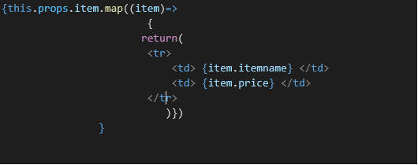

1. In OnlineShopping class, create an array of Cart and initialize 5 items.

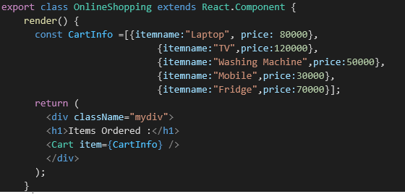

1. Loop through these items and display the data as shown below:

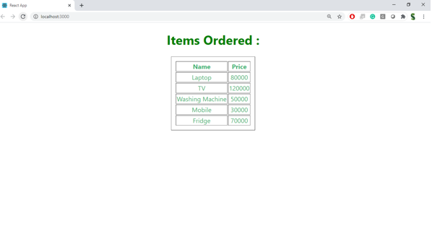

**Source Code:**

**Cart.js:**

import React, { Component } from 'react';

class Cart extends Component {

render() {

return (

<>

{this.props.items.map(item => {

return (

<tr key={item.itemname}>

<td>{item.itemname}</td>

<td>₹{item.price}</td>

</tr>

);

})}

</>

);

}

}

export default Cart;

**OnlineShopping.js:**

import React, { Component } from 'react';

import Cart from './Cart';

class OnlineShoppingClass extends Component {

constructor(props) {

super(props);

this.cartItems = [

{ itemname: "Laptop", price: 65000 },

{ itemname: "Smartphone", price: 25000 },

{ itemname: "Headphones", price: 2500 },

{ itemname: "Keyboard", price: 1200 },

{ itemname: "Backpack", price: 1500 }

];

}

render() {

return (

<div>

<h1>🛒 Online Shopping Cart</h1>

<table border="1" cellPadding="10" style={{ margin: 'auto' }}>

<thead>

<tr>

<th>Item Name</th>

<th>Price</th>

</tr>

</thead>

<tbody>

<Cart items={this.cartItems} />

</tbody>

</table>

</div>

);

}

}

export default OnlineShoppingClass;

**App.js:**

import React from 'react';

import './App.css';

import OnlineShopping from './OnlineShopping';

function App() {

return (

<div className="App">

<OnlineShopping />

</div>

);

}

export default App;

**Output:**

